**ASSIGNMENT 1**

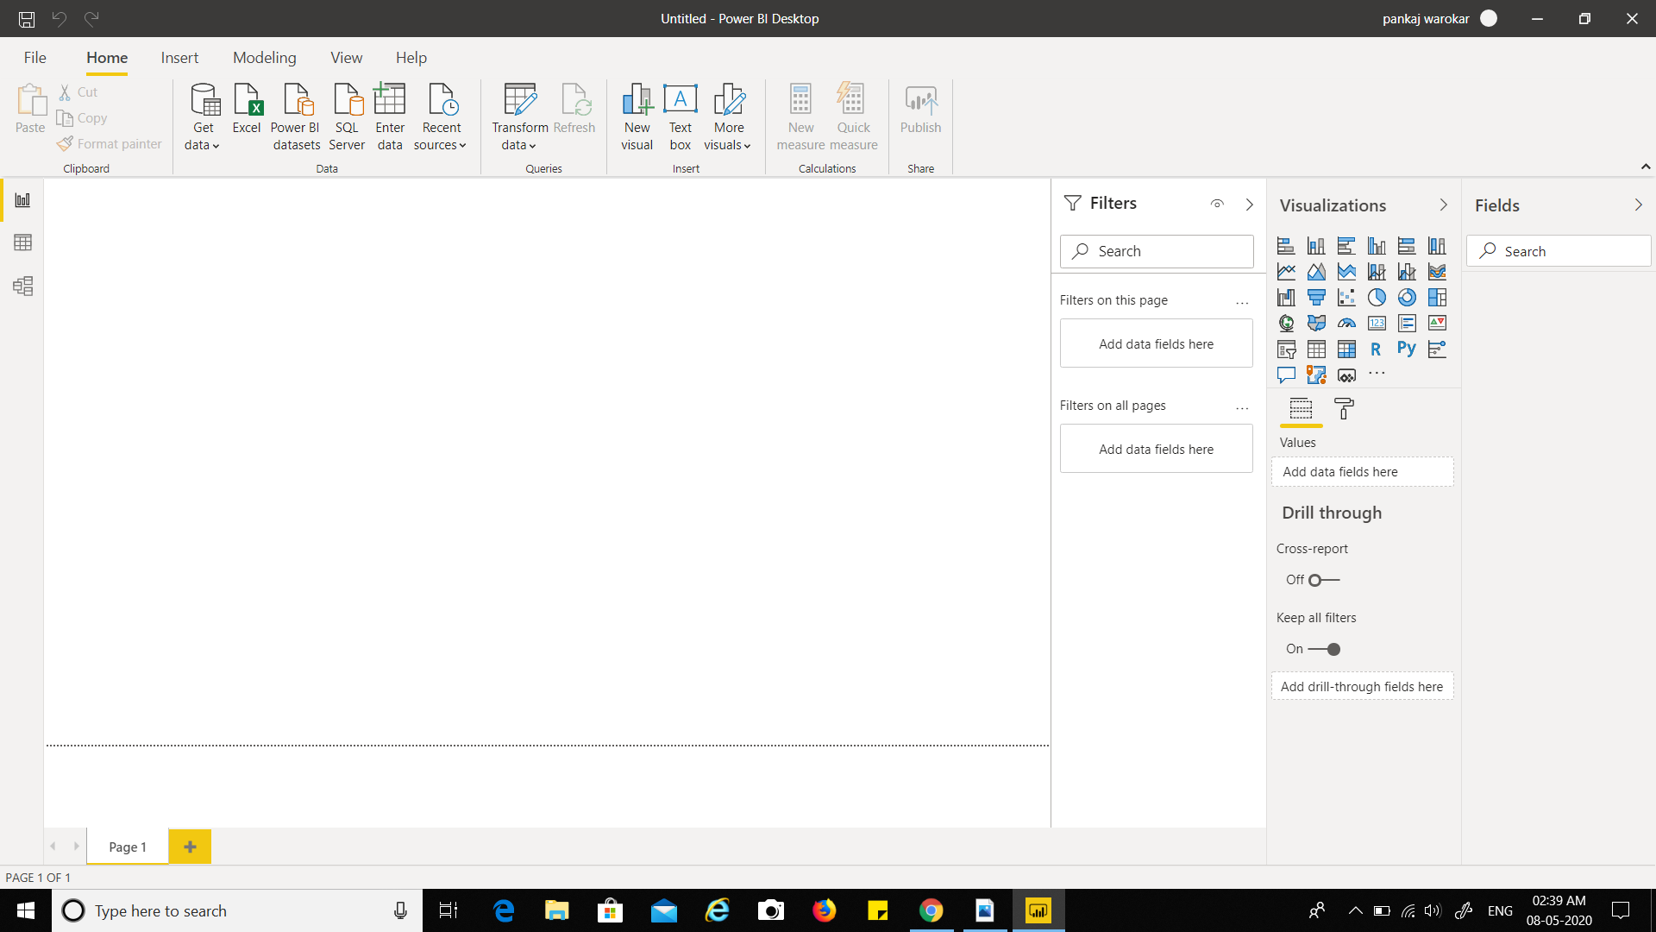**REPORT VIEW**

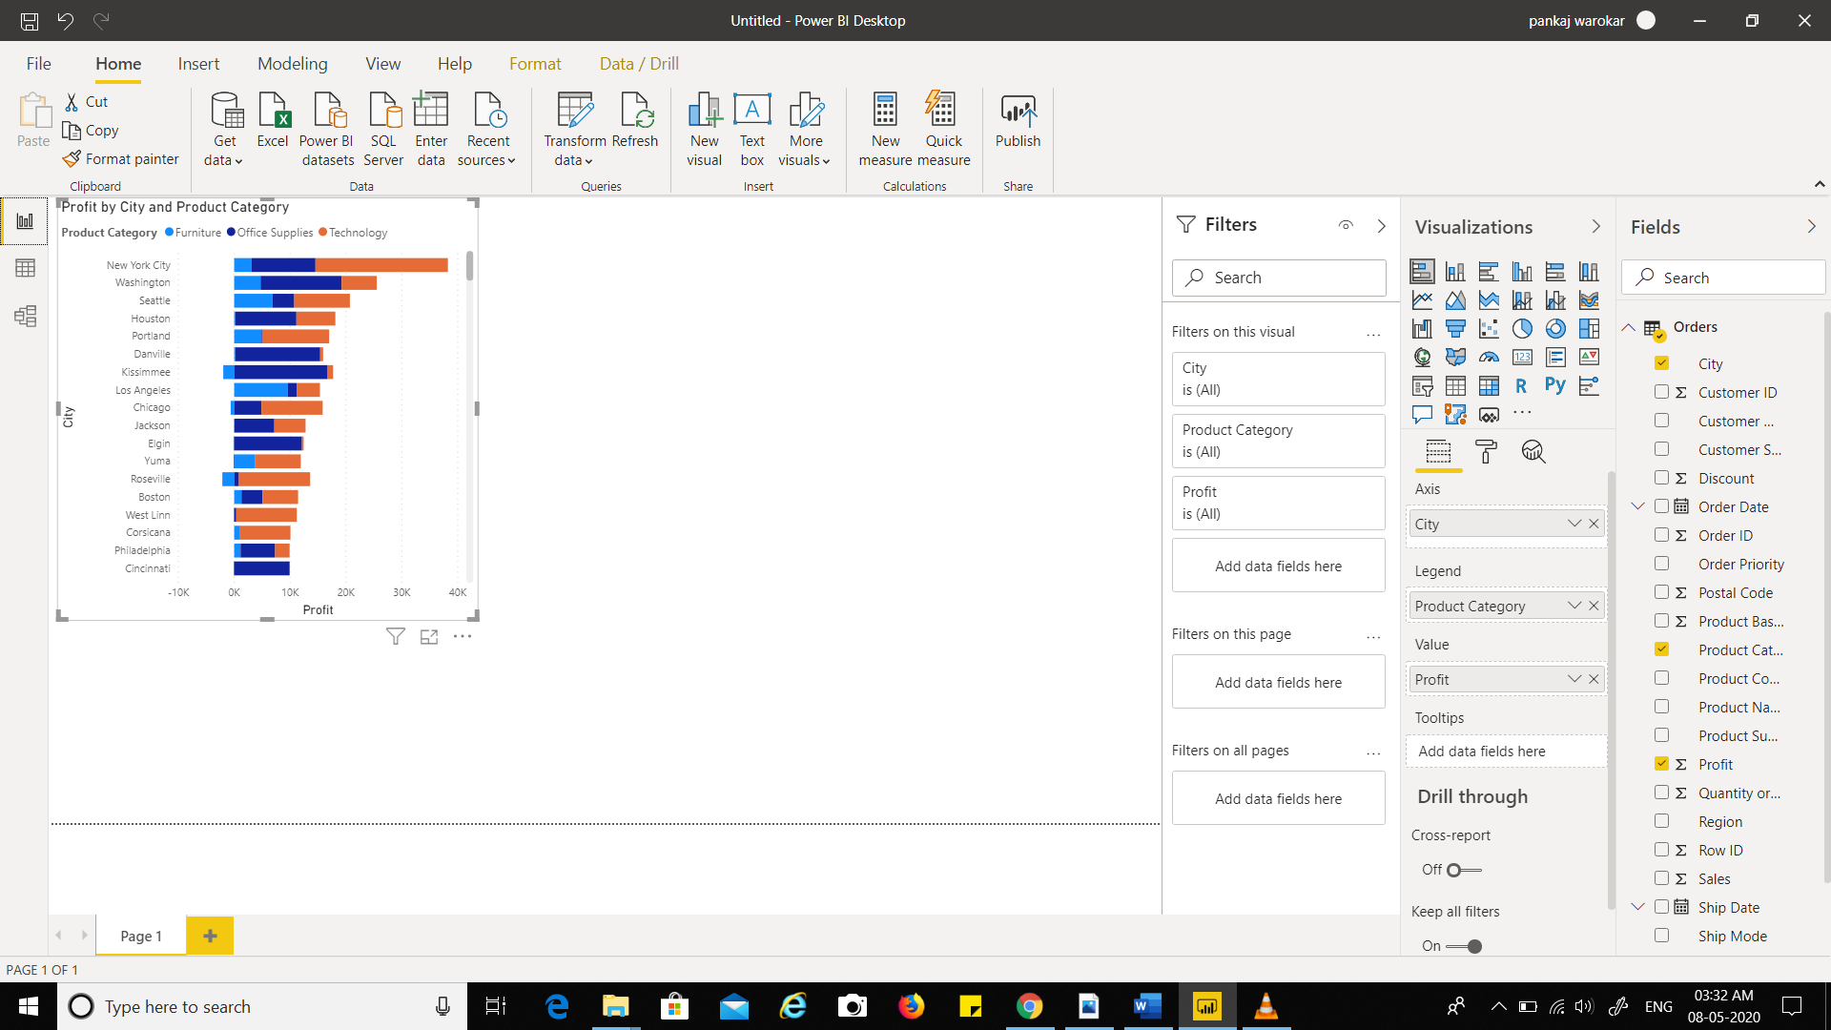**DOCUMENT REPOER VIEW**

**DOCUMENT DATA VIEW**

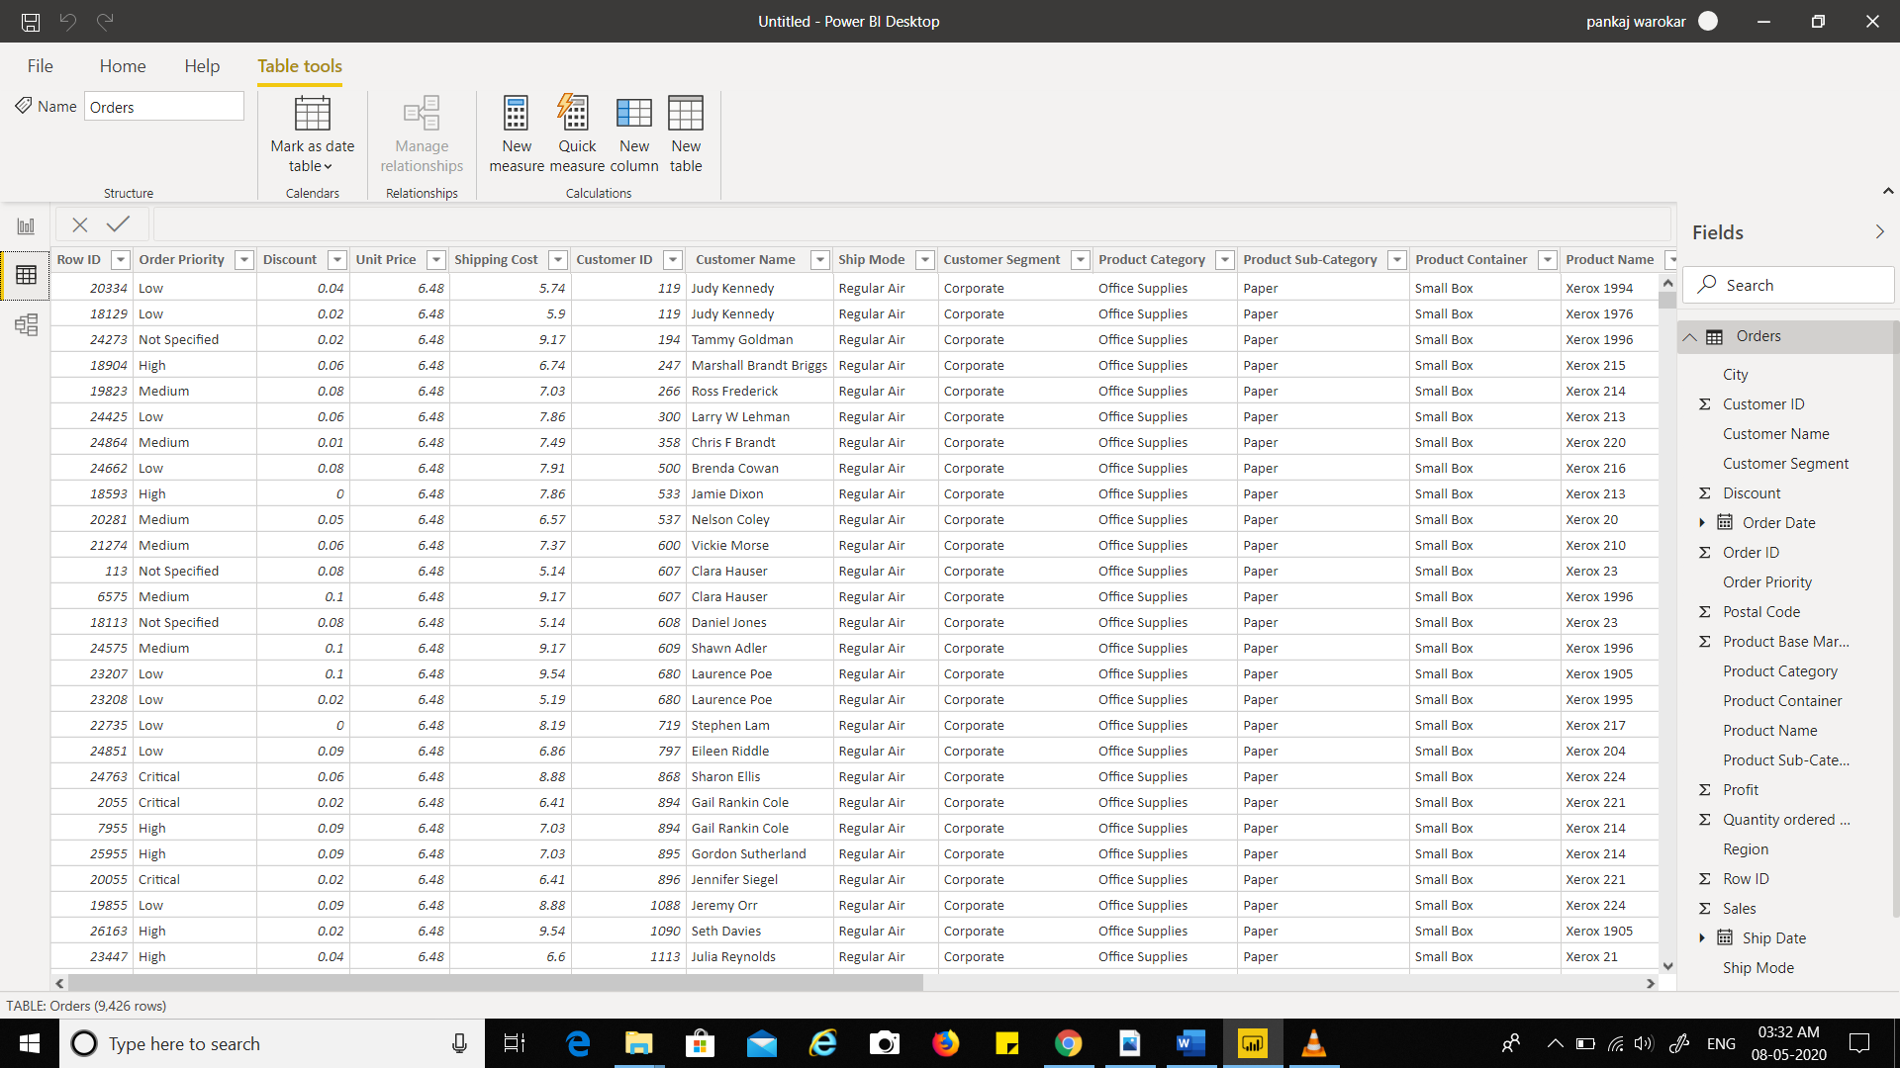

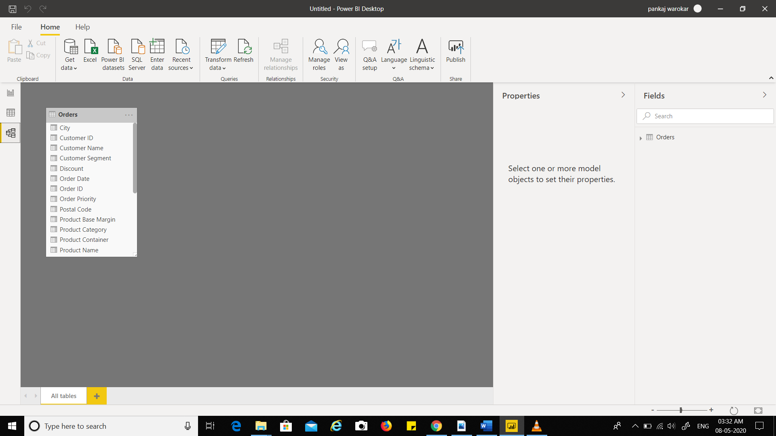**DOCUMENT MODEL VIEW**

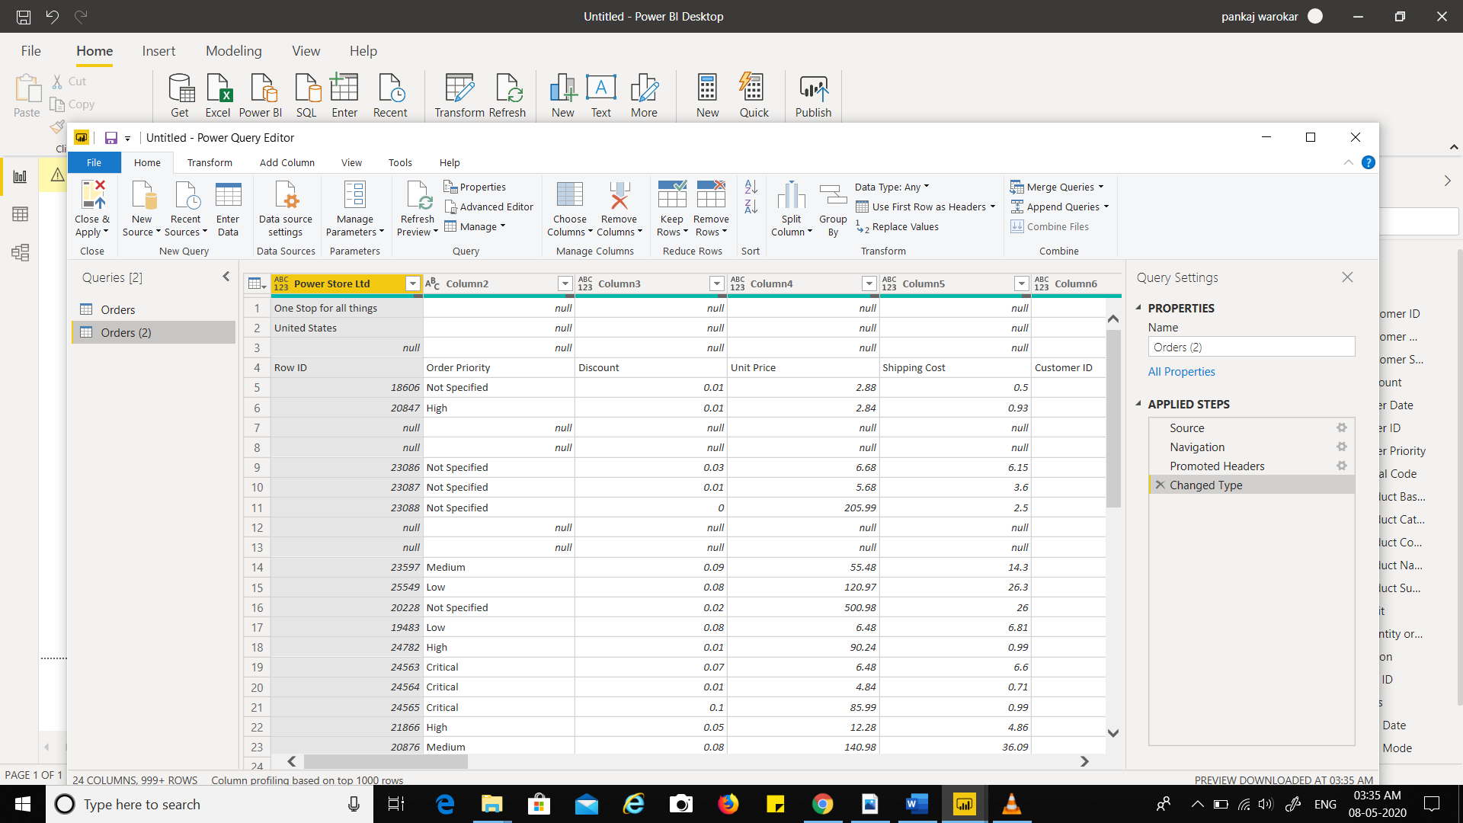**DOCUMENT POWER QUERY EDITOR**

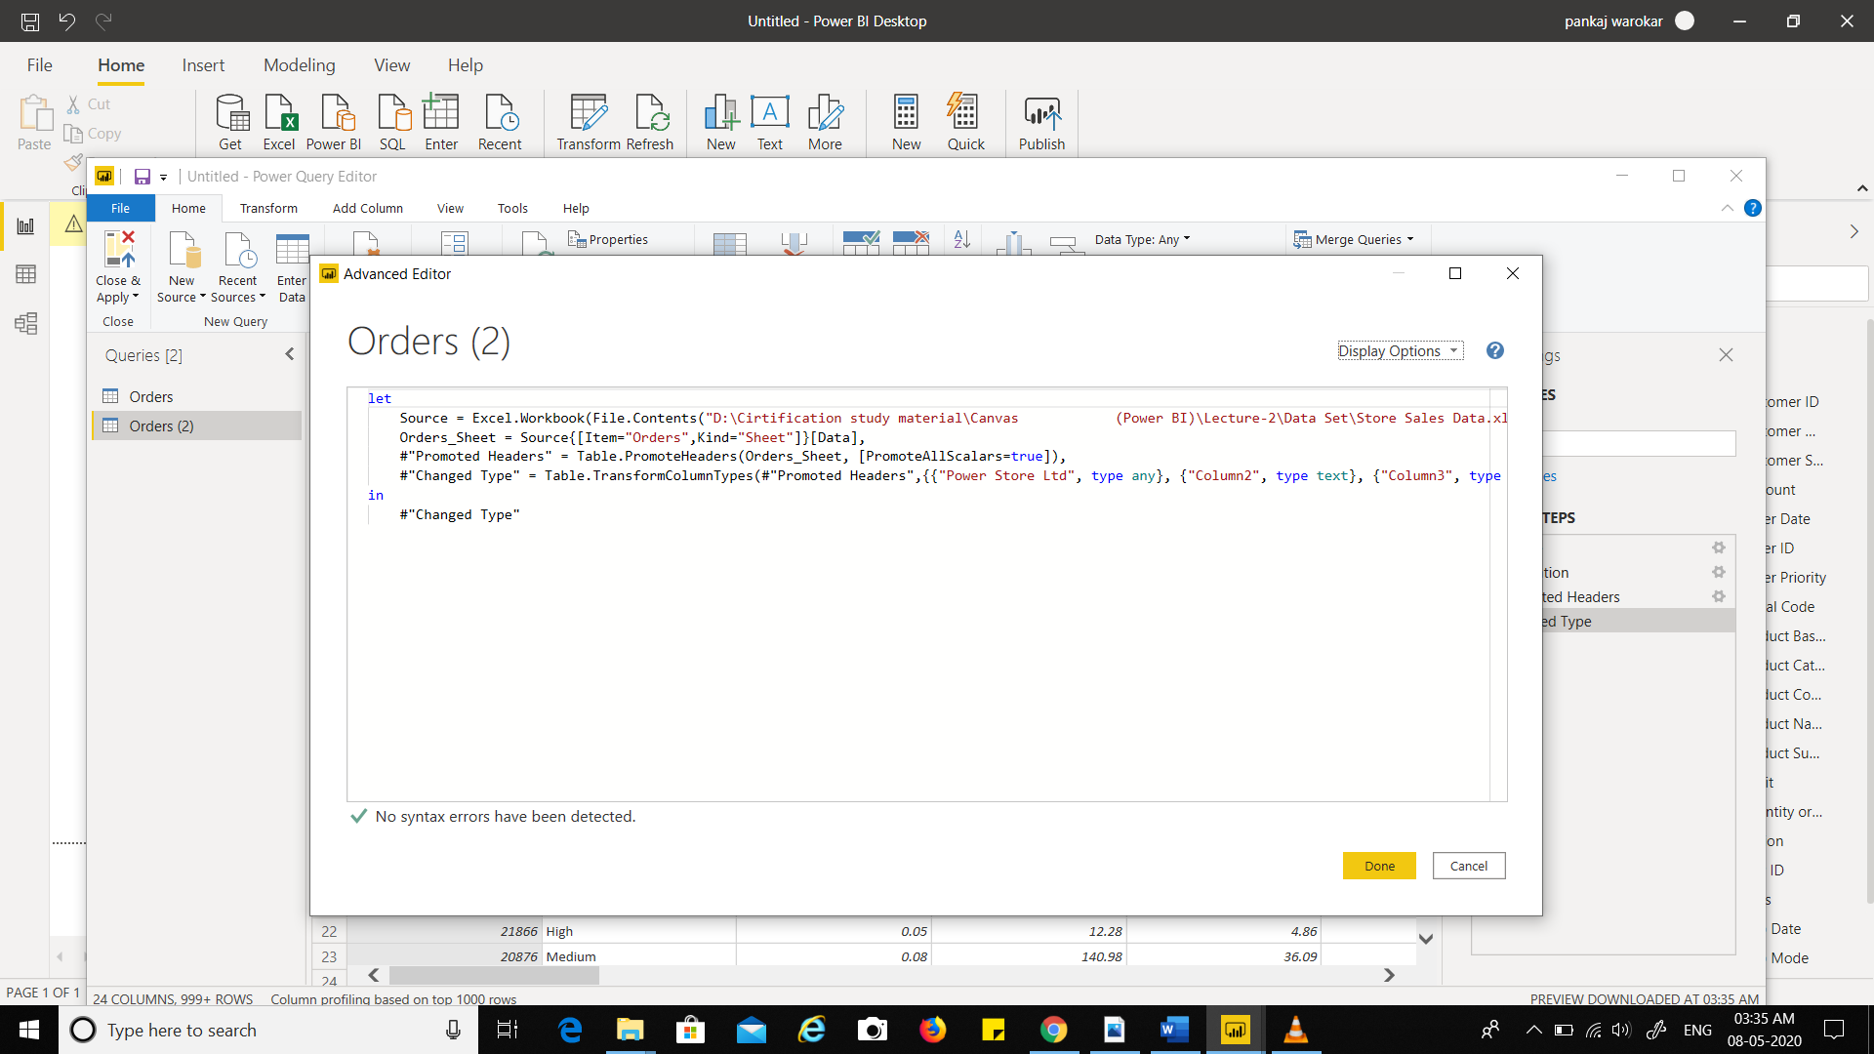**ADVANCE EDITOR**

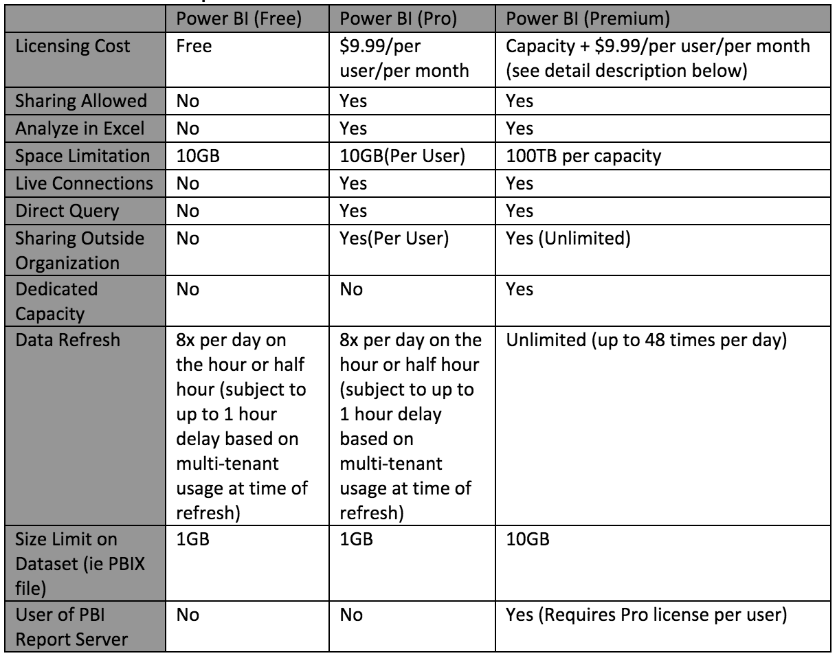**Power BI Desktop/ Pro / Premium**

**Pricing of Power BI**

1. Power BI comes in three levels – Desktop, Pro, and Premium
   1. The Desktop level is **free** for individual users.
   2. The Pro plan costs $9.99 per user per month. **(760.34 Rs)**
   3. The Premium plan starts at $4,995 a month per dedicated cloud compute and storage resource. **(378082 Rs)**